Project Design Phase-II
Data Flow Diagram & User Stories

Date | 1 October 2026
Team ID | SWTID-2026-5148
Project Name | Implement Client Script & UI Policy (Incident)
Maximum Marks | 4 Marks
Team: Mathangi S (Team Leader), Meena Varshini T P, Mirthika R, Muthu Priya U | Team Size: 4
Data Flow Diagrams:
A Data Flow Diagram (DFD) is a traditional visual representation of the information flows within a system. A neat and clear DFD can depict the right amount of the system requirement graphically. It shows how data enters and leaves the system, what changes the information, and where data is stored.
DFD Level 0 – Incident Data Validation (ServiceNow)
DFD Level 1: (Simplified)
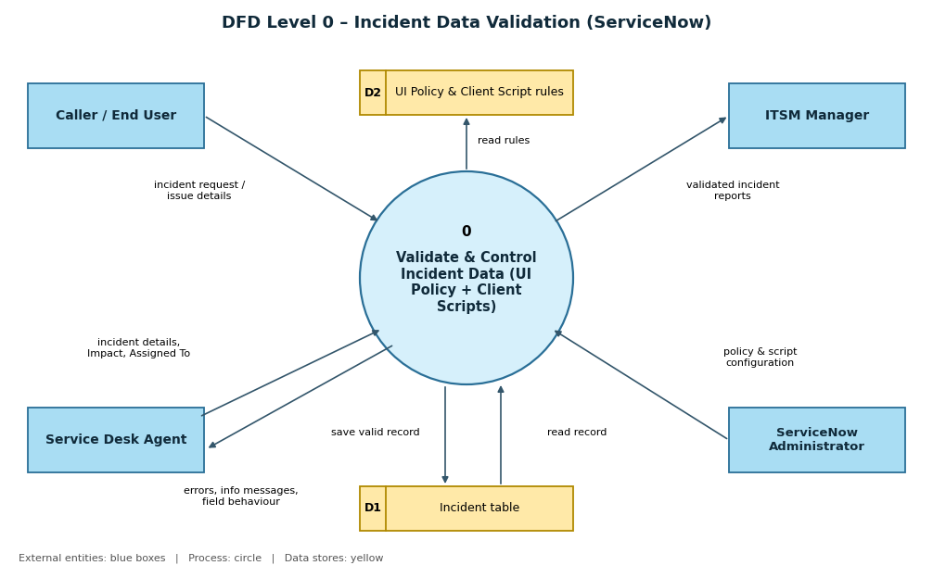
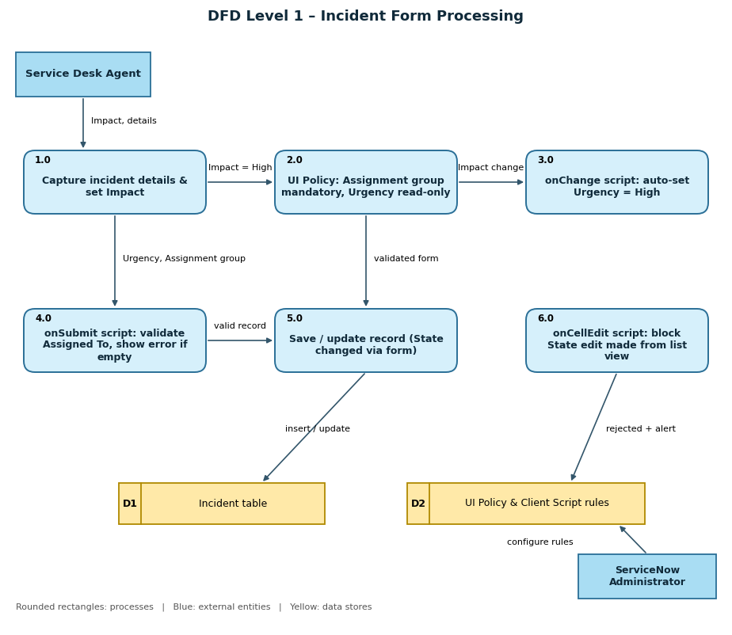

User Stories
Use the below template to list all the user stories for the product.
User Type | Functional Requirement (Epic) | User Story Number | User Story / Task | Acceptance criteria | Priority | Release
Service Desk Agent | Incident Creation & Impact Handling | USN-1 | As a service desk agent, I can set the Impact of an Incident to High so that the system applies the extra controls for serious incidents. | The High Impact Control UI Policy is triggered when Impact = 1 – High | High | Sprint-1
 |  | USN-2 | As a service desk agent, I must provide the Assignment group when Impact is High so that the incident is routed to the right team. | Assignment group becomes mandatory and the form cannot be submitted without it | High | Sprint-1
 |  | USN-3 | As a service desk agent, I want Urgency to be set automatically to High when Impact is High so that priority stays consistent. | Urgency changes to 1 – High and the message "Urgency set to High for High impact incident." is shown | High | Sprint-1
 |  | USN-4 | As a service desk agent, I want Urgency to be read-only while Impact is High so that it cannot be set to a mismatched value. | Urgency is visible but cannot be edited when Impact = High | Medium | Sprint-1
 | Save Validation | USN-5 | As a service desk agent, I am prevented from saving a High-impact Incident without Assigned To so that no serious incident is left unowned. | The record is not saved and the error "Assigned To is mandatory for High impact incidents." appears on the field | High | Sprint-2
 |  | USN-6 | As a service desk agent, I can save the Incident once Assigned To is filled so that valid records are submitted without errors. | The Incident is saved successfully with no error message | High | Sprint-2
 | Reverse Behaviour | USN-7 | As a service desk agent, when I change Impact from High to Medium, I want the extra controls removed so that I can work normally. | Assignment group is no longer mandatory, Urgency is editable again and the record saves successfully | Medium | Sprint-2
 | State Update | USN-8 | As a service desk agent, I can change the State of an Incident on the Incident form so that I can move it through its lifecycle. | The State change made on the form is saved successfully | High | Sprint-2
ITSM Manager | Data Quality & Control | USN-9 | As an ITSM manager, I want State changes from the list view to be blocked so that status updates follow the validated form rules. | An alert is shown on editing State in the list and the State value remains unchanged | High | Sprint-2
 |  | USN-10 | As an ITSM manager, I want every High-impact incident to have an assignee and group so that reports and SLAs are accurate. | No High-impact incident can be saved with Assigned To empty | Medium | Sprint-3
ServiceNow Administrator | Configuration | USN-11 | As an administrator, I can create and activate the UI Policy and its actions on the Incident table so that conditional field behaviour is enforced. | High Impact Control UI Policy is active with Reverse if false enabled; Urgency action is read-only | High | Sprint-1
 |  | USN-12 | As an administrator, I can create onChange, onSubmit and onCellEdit Client Scripts on the Incident table so that data is validated in the browser. | All three Client Scripts are active and run on the Incident table | High | Sprint-1
 | Testing | USN-13 | As an administrator, I can run the test activities so that I can confirm all configured behaviours work as expected. | Mandatory enforcement, successful save, reverse condition, list-edit blocking and form update tests all pass | Medium | Sprint-3
Caller / End User | Incident Submission | USN-14 | As a caller, I want my high-impact issue to reach the support team with complete details so that it is handled quickly. | The Incident record contains Impact, Urgency, Assignment group and Assigned To | Medium | Sprint-3

